Wheatfield Township
Parks and Recreation Plan

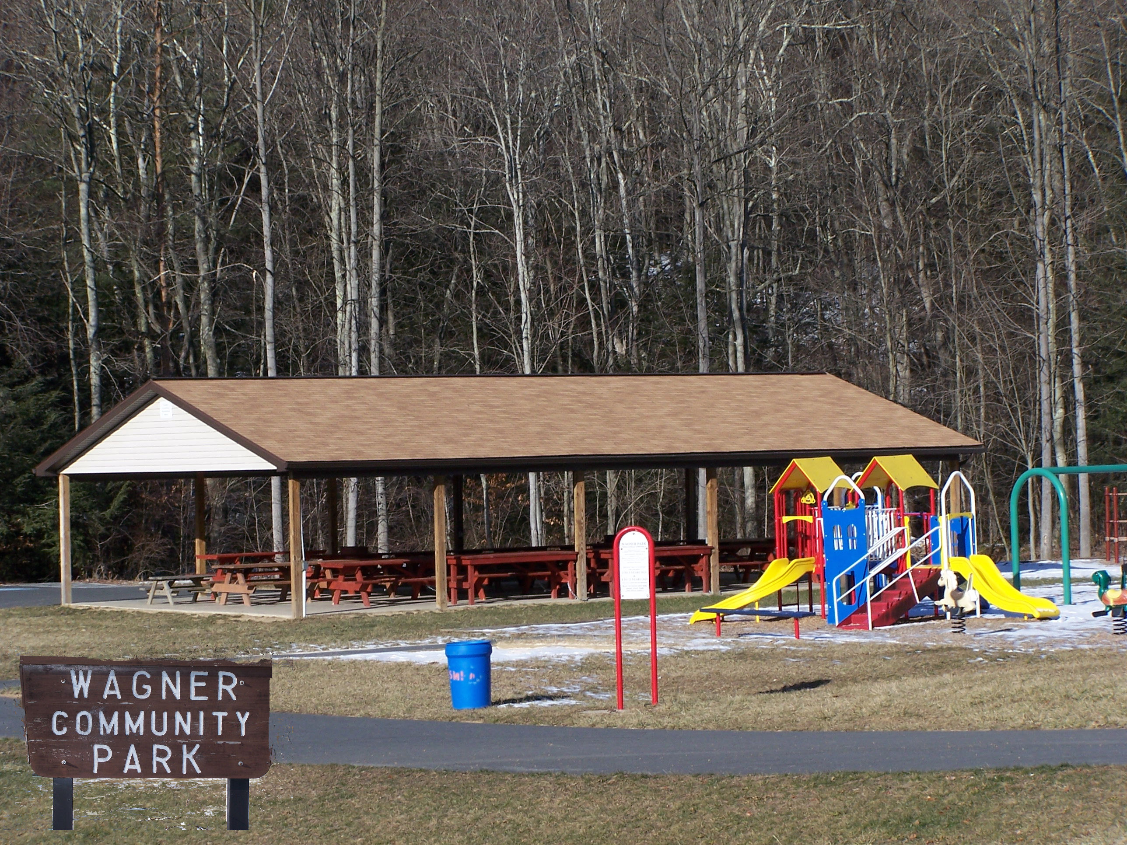

Wheatfield Township
Parks and Recreation Plan

Mission Statement:

The Wheatfield Township Park and Recreation Board (WTPRB) is committed to providing our citizens with Park & Recreation opportunities and preserving Open Spaces.

Goals:
- Continue to implement the Master Site Plan at Wagner Park.
- Establish a Green Corridor to connect Miller, Centre and Penn Township via Little Juniata Creek.
- Address present and future needs for Park and Recreation in the township.
- Establish contact with the surrounding townships (Carroll, Centre, Miller, Penn) Recreation Boards.
- Pursue acquisitions for Open Space of land parcels adjoining Wagner Park.

Wagner Park:
Wagner Park is the only Park in Wheatfield Township. The Park was dedicated to Wheatfield Township August 13, 1991 by Mildred B. Wagner for the purposes of outdoor recreation, land conservation/preservation of aesthetic value, protection of natural habitats (fish, wildlife, plants and similar ecosystems) and the conducting of education programs facilitating those purposes. (Perry County Deed Book 0637 page 263)
The WTPRB is managing grant opportunities to continue the implementation of the Wagner Park Master Site Plan. The service work of volunteers, organizations and township employees has morphed the vision for Wagner Park to a successful, growing asset in the community.
Wagner Park is used by community groups, families and individuals. The trout stream that flows through the park, Little Juniata Creek, is used by fisherman from all over central PA. The stream is stocked by the PA Fish and Boat Commission and the Duncannon Sportsmen Association.
Wagner Park is maintained by the WTPRB and funded by Wheatfield Township. Funding is crucial to the continued maintenance of the park for the community.

Other Areas of Recreation:

The Juniata River, Shermans Creek, PA State Game Lands and the Duncannon Sportsmen Association provide many recreational opportunities to include:
Hunting, Fishing, Boating, Canoeing, Camping, Hiking, Shooting and Archery Ranges.

Wheatfield Township

Parks and Recreation Plan

WTPRB Future:
1. Manage resources and funding from the Township Supervisors.

2. Pursue alternate forms of funding, grants, building & development fees.

3. Evaluate Township demographics for recreational the needs of our community.

4. Exchange information with surrounding Townships about how and where they are establishing Parks and Open Spaces.

5. The Dellville Covered Bridge ‘proposed park’ area will most likely be turned over to the Wheatfield Township for maintenance. The ‘proposed park’ is an anticipated expenditure for the WTPRB budget.

